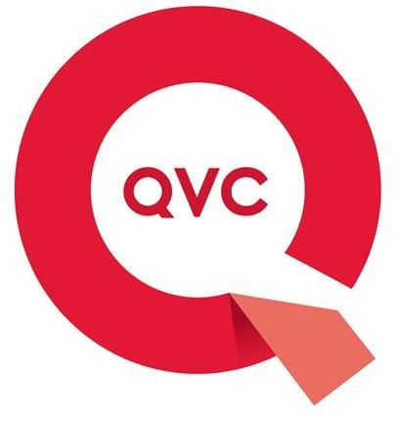 ASSOCIATE APPLICATION DEVELOPER

QVC is a multimedia retailer that puts its multi-channel platform at the service of shopping: TV, web, social media and apps are the means by which we create authentic and two-way relationships with those who follow us, feeding each other to grow constantly.

Through the TV (digital terrestrial and tivùsat channel 32), streaming on its website, on the QVC Italia Facebook page, on the app for iOS and Android, QVC offers 17 hours of direct a day, seven days a week, 364 days a year.

QVC is looking for a graduate student interested in participating in development, configuration, implementation and support of application systems.
This is an IT apprenticeship position, responsible for support and development efforts for the Enterprise Data Management (EDM) area in support of internal systems and customers. The ideal candidate should have knowledge of data warehousing best practices and techniques and environments including Cloud deployments. Will work with the global EDM Development teams, Infrastructure teams, other IT members, business analysts, and external resources.

The Job:
- Assists in developing, coding, configuring, and testing programs from clear specifications for straightforward assignments.
- Prepares documentation of all procedures used in systems, including supporting documentation and application user guides, under guidance.
- Provides first level troubleshooting, technical and operational support under guidance.
- May develop detailed flowcharts to show processing logic.
- Analyzes a chain of events and applies technical knowledge following established procedures and/or detailed specifications.
- Escalates issues when required
- Shares knowledge effectively with other team members.
- Cooperates with and works effectively with other IT team members.
- Responsible for writing documentation / processes / procedures in a clear, concise manner, adhering to standards.
- Interface with business analyst; projects managers and clients to respond to questions and provide support
- Communicates effectively with senior team members.

Requirements:
- Degree in Computer Science/IT
- Academic knowledge of ETL processes
- Knowledge of SQL programming
- Informatica ETL tool knowledge
- Cloud development knowledge is considered a plus
- SCRUM knowledge is a plus
- MS Office
- English: intermediate

Technical skills
- Developing an understanding of the existing applications and systems, with the ability to learn and apply knowledge quickly.
- Possesses basic understanding in one or two programming languages, tools and technologies, with the ability to learn and apply knowledge quickly.
- Is aware of various application development methodologies.
- Developing an understanding of the technical architecture, application landscape and IT environment, as well as tools used in development, deployment and testing.

Constract:
Apprenticeship

Place of work:
Brugherio (MB)

How to apply:
Please send your cv, following the required steps at this link: https://qvc.wd5.myworkdayjobs.com/en-US/QVCEurope/job/Italy-Monza-e-Brianza-Brugherio/Associate-Application-Developer_R35764 a: andrea.bianchessi@qvc.com

Deadline:
02/07/2019

Il CV dovrà contenere l’autorizzazione al trattamento dei dati personali ai sensi del D. Lgs. n. 196/2003 e ss.mm. e ii. e dell’art. 13 GDPR (Regolamento UE 2016/679) ed attestazione di veridicità ai sensi del DPR n.445/2000.
Il presente annuncio è rivolto ad ambo i sessi, ai sensi della normativa vigente.

