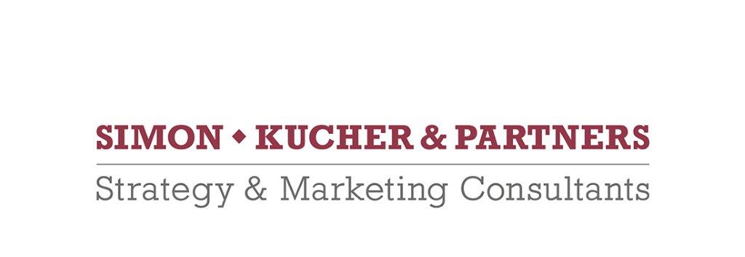

Simon-Kucher & Partners is a global consulting firm with more than 1,300 professionals in 38 offices worldwide focusing on TopLine Power®. Founded in 1985, the company has more than 30 years of experience providing strategy and marketing consulting and is regarded as the world’s leading pricing advisor.

Simon-Kucher & Partners is recruiting 2 (Associate) Consultants

The job we offer:
New consultants are involved in all phases of our projects, with a heavy focus on analysis and
research to support developing and implementing practical solutions for our clients.

What we are looking for:
the candidate we are looking for should comply with the following skills:
- Outstanding accademic background (i.e., laurea magistrale in ingegneria gestionale/meccanica/…)
- Very fluent business English (written and spoken). Languages skills will be tested
- Italian to be spoken as mother tongue
- Proficient knowledge of MS Office, in particular of Excel and Power Point
- Excellent quantitative and analytical skills
- Strong problem solving skills
- Enthusiasm for working in teams and strong communication skills
- At least one year of work experience (preferred in strategic consultancy)

Contract type:
Permanent contract

Location: Milan, consultants may be asked to join international projects based in Europe, US, ….

To apply:
If you are interested, please submit your application online (see the link below). Be sure to upload your CV and your cover letter naming the files according to the following structure: "CV / CL_Name_Surname_POBA_2019”).
Recruiting season ends on July 30, 2019. Early applications are encouraged.
Simon-Kucher portal:
https://simon-kucher.csod.com/ats/careersite/search.aspx?site=1&c=simon-kucher

For application from Italy:
Il CV dovrà contenere l’autorizzazione al trattamento dei dati personali ai sensi del D. Lgs. n. 196/2003 e ss.mm. e ii. e dell’art. 13 GDPR (Regolamento UE 2016/679) ed attestazione di veridicità ai sensi del DPR n.445/2000.
Il presente annuncio è rivolto ad ambo i sessi, ai sensi della normativa vigente.

