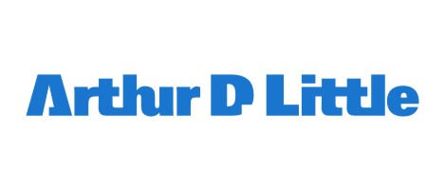
Arthur D. Little is one of the world's foremost consulting firms, with 30 offices located in different countries. Founded in 1886, we help leading organizations create innovation across the full spectrum of their activities, from setting strategy and shaping the organizational culture to developing cutting-edge products and technologies. We are committed to helping clients reinvent their organizations, enhance their capacity for learning and change, and creating lasting value.
At Arthur D. Little, our multidisciplinary teams focus on innovation to facilitate change, develop strategies, improve operations, and create new products and services. We are committed to finding new insights and new ways to create value for clients, and to developing the skills and experience of our people.
Our sustainability and risk specialists are unique in their ability to apply technical expertise and industry knowledge with a broad business perspective. We help companies manage their environmental, health, and safety risks effectively to maintain their license to operate and meet the needs of their business in a sustainable and responsible manner.
Job location: Rome

Initial contract: 6 months’ internship (with possibility of subsequent permanent position) for newly graduates; full-time contract for people with 1-3 years’ experience
Description of work: Analyst in the Sustainability & Risk practice
Candidate Profile:
- Degree in engineering (environmental, chemical, nuclear, energy, mechanical, …)
- Studies and/or related experience in Sustainability Management, Corporate Social Responsibility, CSV and/or Risk Analysis, Safety and Loss Prevention.
- Fluent in English
Applications and deadline:
If you are interested in this position, you can send your C.V. and motivation letter to careers.italy@adlittle.com, mentioning the ‘Analyst Sustainability & Risk Rome’ reference in the subject line.
Deadline for applications: July 31, 2019
The selected candidates will attend a first-round interview, which will take place at our premises in Rome at the earliest possible date. We will only contact interesting applications.

In consideration of the fact that your data shall remain in our archive, we assure that we respect absolutely their confidential nature. Anytime, you can exercise your rights as provided in the GDPR (679/2016) on Privacy. You can consult the data and require their modification or cancellation, writing to the management of Arthur D. Little S.p.A., Corso Monforte 54, 20122 Milano or arthurdlittle.privacy@legalmail.it
When sending your CV, please indicate your consent to the use of your data (law 679/2016). For further information, please check our privacy notice in our website http://www.adlittle.com/en/notice-privacy .

