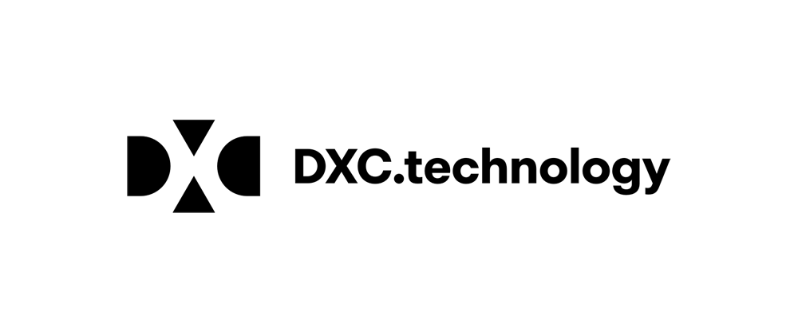

la società DXC TECHNOLOGY è alla ricerca di
N. 50 APPLICATION JUNIOR DEVELOPER (50)

Il lavoro:
- Codes and programs enhancements, updates, and changes for portions and subsystems of end- user applications software running on local, networked, and Internet- based platforms based on specific requirements and instructions.
- Executes established test plans and protocols for assigned portions of code; identifies, logs, and debugs assigned issues.
- Develops relationships with internal and outsourced development partners on software applications design and development.
- You will learn how to use the major frameworks, programming languages, development environments and next generation skills (e.g.: Java/JEE, Spring MVC, JSF, Cloud, Mobility, AWS, MS Azure, Scrum…).

Requisiti:
- corso di laurea triennale e/o magistrale in INGEGNERIA INFORMATICA
- A proven passion for IT sector
- The ideal candidate has relational and analytical skills, with constant focus on the goals, team-working, ability and proficient Italian and English (both oral and written).

Tipologia contrattuale: contratto a tempo indeterminato

Sede di lavoro: Cernusco sul Naviglio (MI), Pomezia (RM)

N. 30 ANALYTICS JUNIOR DEVELOPER
Il lavoro:
- Design and Develop for important projects:
- Business Intelligence, Analytics and Data Warehouse application architectures (DBMS, Data
Integration, Information delivery, Analytics, Machine Learning, IoT, etc.).
- Big Data Analytical Platforms (based on Hadoop, Google Cloud Platform, Amazon Web Services and related components and technologies).
- Design and Develop prototypes &amp; proof-of-concepts in support of presales activities as well as support the development of standardized analytic offerings across multiple industries
- Learn and manage knowledge sharing within an international Big Data/Analytics community.

Requisiti:
corso di laurea magistrale in INGEGNERIA INFORMATICA

- Experiences in software development universities’ projects with programming languages like Java, Python,
- A proven passion for IT sector.
- The ideal candidate has relational and analytical skills, with constant focus on the goals, team-working ability and proficient Italian and English (both oral and written).

Tipologia contrattuale:
contratto a tempo indeterminato

Sede di lavoro: Cernusco sul Naviglio (MI), Roma (RM)

Per candidarsi:
inviare il proprio cv aggiornato a: irusso3@dxc.com entro il ………30/06/2019………….
inserendo in oggetto “Rif. Contatto Ufficio Placement Politecnico di Bari”

Il CV dovrà contenere l’autorizzazione al trattamento dei dati personali ai sensi del D. Lgs. n. 196/2003 e ss.mm. e ii. e dell’art. 13 GDPR (Regolamento UE 2016/679) ed attestazione di veridicità ai sensi del DPR n.445/2000.
Il presente annuncio è rivolto ad ambo i sessi, ai sensi della normativa vigente.

