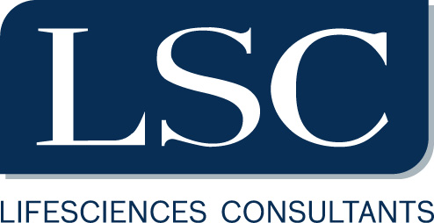

Company:
LifeSciences Consultants was founded in April 2004 by professionals from major global consultancy firms and has been growing double digits since then. Our business interest is uniquely within Lifesciences, Pharmaceutical and Biotech. Our major clients are among the largest Corporations in the industry. Assignments cover Strategy, Marketing and Sales, cases in markets like USA, EMEA and LATAM.
We receive encouragement and appreciation by all our clients for our delivery dedication and expert insight. To respond to a continuously growing demand we are currently recruiting at multiple seniority level in all our offices to grow our consulting staff which in 2016 has employed around 30 consultants.
A fast track career at LSC demands strong leadership, initiative, international mindset, and acquired expertise. We will offer you the opportunity to work for Global Pharma Leaders, an international team of talented colleagues and full exposure to a variety of engagement-based responsibilities. In addition, you will be part of a learning and development program aimed at increasing your market knowledge and accelerating your career opportunities.

We regularly sponsor structured education programs (for instance, in a Master format) to further enhance our consultants confidence and industry-specific knowledge.
Job description:
LSC is looking for high caliber candidates to recruit as a Business Analysts in our European Office (Milan) to assist in our ongoing expansion. BAs will be members of projects teams and are expected to run analytical and insight development activities around a set of internal assignments. A fast track career at LSC demands strong leadership, initiative, international mindset, and expertise. We will offer you the opportunity to work for Global Pharma Leaders and with an internal international team of exceptional people and a full exposure to a variety of engagement-based responsibilities. In addition, you will be part of a learning and development program aimed at increasing your market knowledge and accelerating your career opportunities.

Responsabilities:
- Consult with other team members to identify,
- Clarify and resolve complex issues critical to clients’ strategic and operating success by conducting interviews,
- Gathering required data,
- Executing analyses,
- Testing quality of data and reconciling data across sources,
- Presenting facts and evidence in meetings and serving as an effective support resource to team in client meetings;
- Interpret results from project components and translate these findings into clear,
- Compelling, and pragmatic recommendations and solutions;
- Plan, manage, and structure small work streams, as well as support execution of client projects, while working with other team members, and securing delivery of high quality team output

Requirements:
Bachelor and Master degree in Engineering with final grades starting from 105/110, English C1, international experience

Skills:
Specific competences
Competent user of Microsoft Office (especially ppt and excel);
Fluency in English is mandatory; working knowledge of French, German or Spanish is considered
as an advantage

Soft skills
Highly analytical; Excellent verbal and written communications skills; Ability to work as part of a team in solving challenging problems and communicating results; Ability to perform several tasks simultaneously to meet deadlines; Demonstrates initiative and result orientation; Strong motivation and passion for Management Consulting; Interest in working in a challenging and dynamic international environment with accelerated career opportunities.

Contract type:

Internship or permanent full-time contract

Location:
Milan

Per candidarsi:
inviare il proprio cv aggiornato a: …elitvinova@consultingls.com……………….. ……………..entro il ……04/01/2021…………….
inserendo in oggetto “Rif. Contatto Ufficio Placement Politecnico di Bari”

Il CV dovrà contenere l’autorizzazione al trattamento dei dati personali ai sensi del D. Lgs. n. 196/2003 e ss.mm. e ii. ed attestazione di veridicità ai sensi del DPR n.445/2000.
Il presente annuncio è rivolto ad ambo i sessi, ai sensi della normativa vigente.

