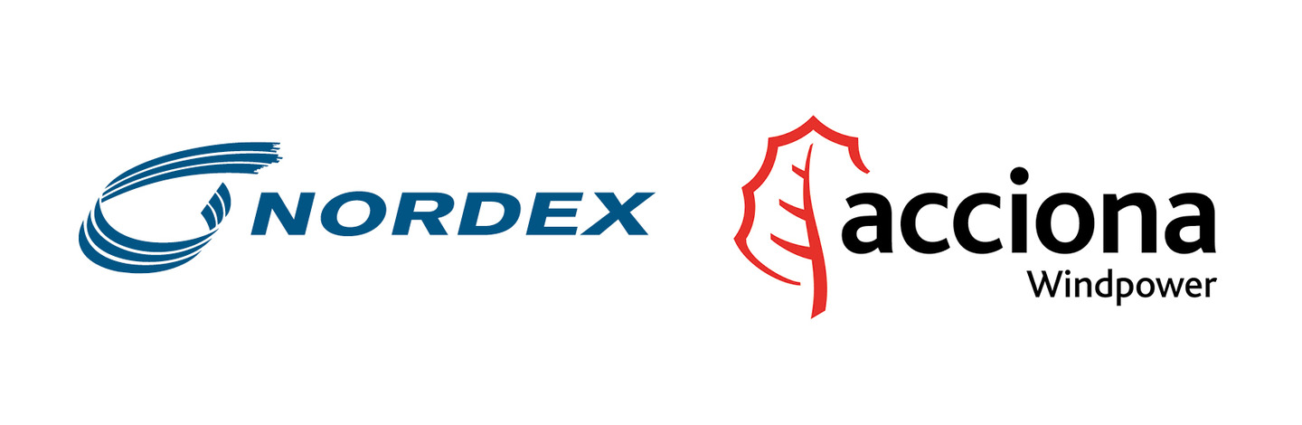

Nordex Acciona Windpower combine decades of experience in designing, constructing and operating wind turbines, delivering more than 18 GW of sustainable energy worldwide.

Nordex Acciona Windpower is currently looking for an intern / working student for the Turnkey Management Department.

Job description:
Support Nordex Acciona Windpower internal design centre within Turnkey Management in tendering and construction phase.
Main tasks includes:
· Review customers’ tender documentation.
· Prepare clarifications and deviations lists to tenders issued from our customers.
· Elaborate a basic concept for the electrical infrastructure of the wind farm (medium voltage cables, substation, overhead lines, etc.).
· Calculate most cost effective wind farm MV configuration: step up transformers, optimal cable diameter, cables losses, etc.
· Define basic wind farm substation layout and equipment list.
· Prepare RfQ (Request for Quotations) for electrical works.
· Review electrical works subcontractors proposals.
· Support Tender Managers on the technical assessment of subcontractors bids.
· Lead technical negotiations with subcontractors and customers.
· Give technical support to the Project Manager during the project construction phase in relation to electrical issues specific of the project.
· Prepare standardized Contract, Technical Specification and Purchase Specifications Templates for Electrical Works.

Requirements:

Bachelor and Master Degree in Mechanical or Electrical Engineering.
Excellent English language skills. Spanish and German are an advantage.
Willing to travel on a regular basis for business purpose abroad (20%).

Skills

- Office suite
- AutoCAD is a plus
- DIgSILENT or a similar software is a plus

Contract type:
Internship/contract

Place of work:
Hamburg, Germany

Per candidarsi:
inviare il proprio cv aggiornato a: ufficioplacement@poliba.it entro il 15.10.2016
inserendo in oggetto “Rif. Nordex_Acciona”

Il CV dovrà contenere l’autorizzazione al trattamento dei dati personali ai sensi del D. Lgs. n. 196/2003 ed attestazione di veridicità ai sensi del DPR n.445/2000.
Il presente annuncio è rivolto ad ambo i sessi, ai sensi della normativa vigente.

